Design and Verification of 2:1 Multiplexer and Demultiplexer
Aim
To design and verify a 2:1 Multiplexer and a 1:2 Demultiplexer using Verilog HDL.
Theory / Synopsis
A 2:1 Multiplexer (MUX) selects one of two data inputs, A or B, and routes it to a single output Y based on the value of the select line S. A 1:2 Demultiplexer (DEMUX) performs the reverse operation: it routes a single data input D to one of two outputs, Y0 or Y1, based on the select line S.
Boolean Functions
2:1 Multiplexer:
- Y = S'.A + S.B
1:2 Demultiplexer:
- Y0 = S'.D
- Y1 = S.D
Files to be Created
File name | Purpose
mux_demux.v | MUX / DEMUX RTL
mux_demux_tb.v | Stimulus and VCD generation
Design / RTL Program
// gedit mux_demux.v
module mux2to1 (
input wire A, // input line 0
input wire B, // input line 1
input wire S, // select line
output wire Y // output
);
assign Y = (~S & A) | (S & B);
endmodule

module demux1to2 (
input wire D, // data input
input wire S, // select line
output wire Y0, // output line 0
output wire Y1 // output line 1
);
assign Y0 = (~S) & D;
assign Y1 = S & D;
endmodule
Testbench Program
// gedit tb4.v
module tb4;
reg A, B, S, D;
wire Y;
wire Y0, Y1;

// Instantiate the 2:1 Multiplexer
mux2to1 mux_uut (
.A(A),
.B(B),
.S(S),
.Y(Y)
);

// Instantiate the 1:2 Demultiplexer
demux1to2 demux_uut (
.D(D),
.S(S),
.Y0(Y0),
.Y1(Y1)
);

initial begin
// ---- VCD dump setup ----
$dumpfile("mux_demux.vcd"); // name of the VCD file to be generated
$dumpvars(0, tb4); // dump all signals in this testbench hierarchy

// ---- Apply all input combinations ----
$monitor("Time=%0t S=%b A=%b B=%b Y=%b | D=%b Y0=%b Y1=%b",
$time, S, A, B, Y, D, Y0, Y1);

// MUX select = 0 -> Y should follow A
S = 0; A = 0; B = 0; D = 0; #10;
S = 0; A = 0; B = 1; D = 1; #10;
S = 0; A = 1; B = 0; D = 1; #10;
S = 0; A = 1; B = 1; D = 0; #10;

// MUX select = 1 -> Y should follow B
S = 1; A = 0; B = 0; D = 0; #10;
S = 1; A = 0; B = 1; D = 1; #10;
S = 1; A = 1; B = 0; D = 1; #10;
S = 1; A = 1; B = 1; D = 0; #10;

#10 $finish;
end
endmodule
Truth Table
2:1 Multiplexer
S | A | B | Y
0 | 0 | 0 | 0
0 | 0 | 1 | 0
0 | 1 | 0 | 1
0 | 1 | 1 | 1
1 | 0 | 0 | 0
1 | 0 | 1 | 1
1 | 1 | 0 | 0
1 | 1 | 1 | 1

1:2 Demultiplexer
S | D | Y0 | Y1
0 | 0 | 0 | 0
0 | 1 | 1 | 0
1 | 0 | 0 | 0
1 | 1 | 0 | 1
Simulation Procedure
STEP 1 – Open Terminal
Open a terminal in the experiment folder.
STEP 2 – Load Synopsys Environment
source /synopsys/start.sh
STEP 3 – Compile Using VCS
vcs mux_demux.v mux_demux_tb.v -full64
If compilation is successful, VCS generates the simulation executable:
simv
STEP 4 – Run Simulation
./simv
The terminal displays the input combinations and corresponding outputs Y, Y0, and Y1.
A VCD waveform file is also generated:
mux_demux.vcd
STEP 5 – Open DVE
dve -full64
Other option
dve -full64 &
A DVE environment will open.
DVE Waveform Verification
In DVE:
- Open the testbench hierarchy.
- Locate the signals:
  - A
  - B
  - S
  - Y
  - D
  - Y0
  - Y1
- Add the signals to the waveform window.
- Run/inspect the waveform.
- Verify that Y = A whenever S = 0, and Y = B whenever S = 1.
- Verify that Y0 = D and Y1 = 0 whenever S = 0, and Y1 = D and Y0 = 0 whenever S = 1.
- Confirm that Y0 and Y1 are never both high at the same time, since only one output is active per select value.
The waveform should agree with the truth table.
Expected Result
The 2:1 Multiplexer and 1:2 Demultiplexer were realized using Verilog HDL:
- Y = S'.A + S.B
- Y0 = S'.D, Y1 = S.D
The design was compiled and simulated using Synopsys VCS, and the functionality was verified using DVE waveform analysis, matching the expected truth table.
Output
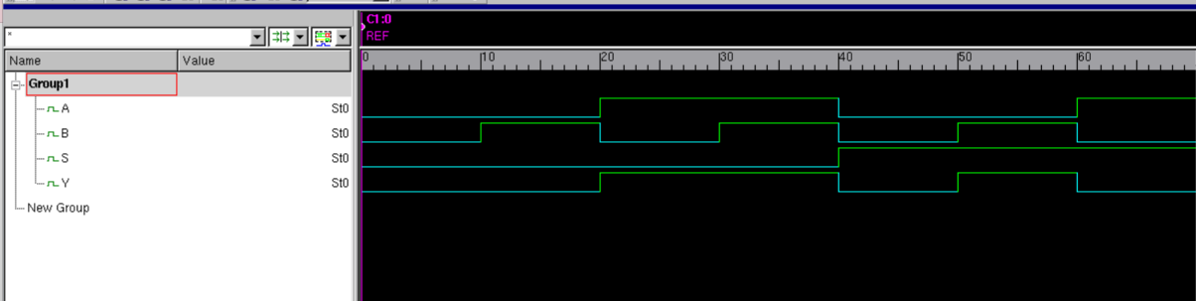

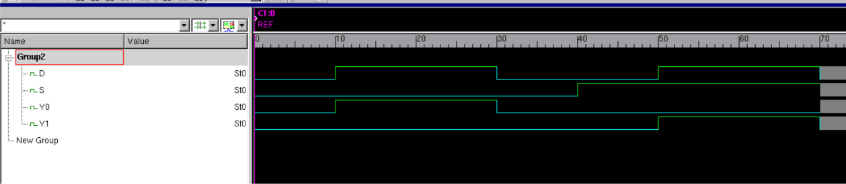
Viva-Voce Questions
- What is a Multiplexer, and why is it called a 'data selector'?
- What is a Demultiplexer, and how does it differ functionally from a Multiplexer?
- How many select lines are required for an 8:1 MUX and a 1:8 DEMUX?
- Write the Boolean expression for a 4:1 Multiplexer.
- What is the purpose of a Verilog testbench?
- Why is a VCD file generated, and what does $dumpvars(0, tb) do?
- What is the purpose of ./simv?
- What is the difference between simulation and synthesis?
- How would you extend the 2:1 MUX design to a 4:1 MUX using two 2:1 MUXes?
Result
Thus, the 2:1 Multiplexer and 1:2 Demultiplexer were designed, implemented using Verilog HDL, successfully simulated using Synopsys VCS, and verified using Synopsys DVE.

